**International Academy of Arts & Sciences Summer Program**

Experience both American and Japanese culture through numerous fun activities! We also provide swimming classes with professional coaches at a local swimming pool.

Dates：6/27/2016 (Mon) -8/19/2016 (Fri)　(4 terms/8 weeks in total)

　　　 *No school on July 4th, due to Independence Day.

You can register daily.

　　　　 Please write down the days you want to enroll for.

Time：9:00am〜2:30 pm

Place：International Academy of Arts and Sciences

　 300 High Street, Closter, NJ 07624

Ages：2.5 -7 years old

Course：**☆ English - Japanese Bilingual Pre-school course**

**1st term Let's learn about America & Tanabata Festival**

**2nd term YOHO We are pirates**

**3rd term Asunaro Japanese Summer Festival**

**4th term Go Go Bugs!**

**☆Swimming lessons (2nd-8th week)**

***Swimming lessons at Pascack Valley Swim Club!***

(http://swimpascack.com/)

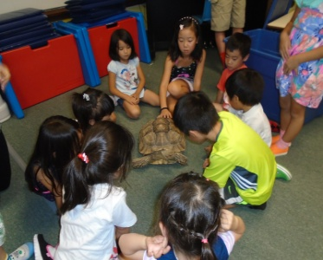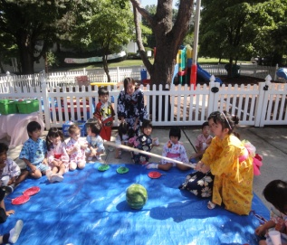

　 Capacity：60 children

Registration Fee：$50

*No Registration fee for the students already enrolled

to IAAS for 2015-16 school year

Tuition : Registration by week

1st Week: $359(No swimming class this week)

2nd Week:$331(Swimming on Tue & Thu, No school on Fri)

3rd - 8th Week: $403/ week(Swimming on Tue & Thu)

Registration by day

No Swimming class day $78 per day

(1st week and Mon, Wed , Fri for 2nd-8th week)

Swimming class day $100 per day

(Tue & Thu for 2nd-8th week)

*You need to register and pay in advance for daily registration too.

*We cannot make up days or give a refund if your child is absent.

　　 *We also have some discount options.

　　　　　　（Please check with your application form)

We will have a van service for some areas. ($12/ ride)

How To Enroll：

Please return the registration form and a check to us.

Make sure that the form is all filled out, properly.

We will send you all the additional documents.

**International Academy of Arts and Sciences**

Tel：201(767)1144

Email：info@asunarokokusai.org

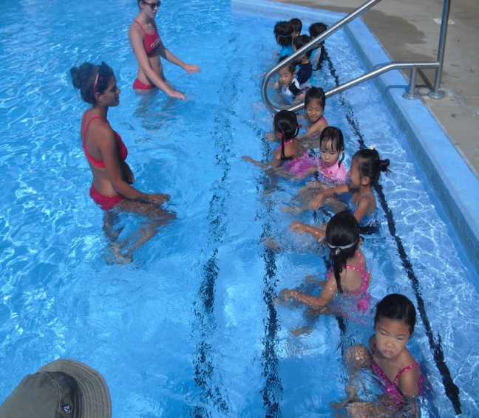

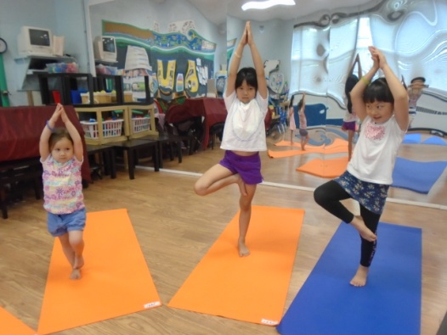

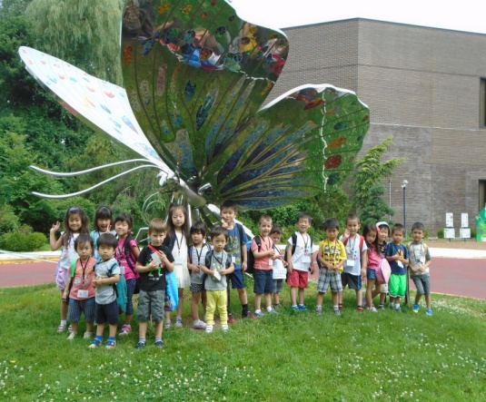

**Register Now!!**

**International Academy of Arts and Sciences**

300 High St, Closter, NJ 07624

Phone：201(767)1144

Email:info@asunarokokusai.org

Blog: http://asunarokokusai.blogspot.com

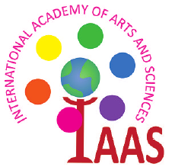 **2016**

**Summer School**

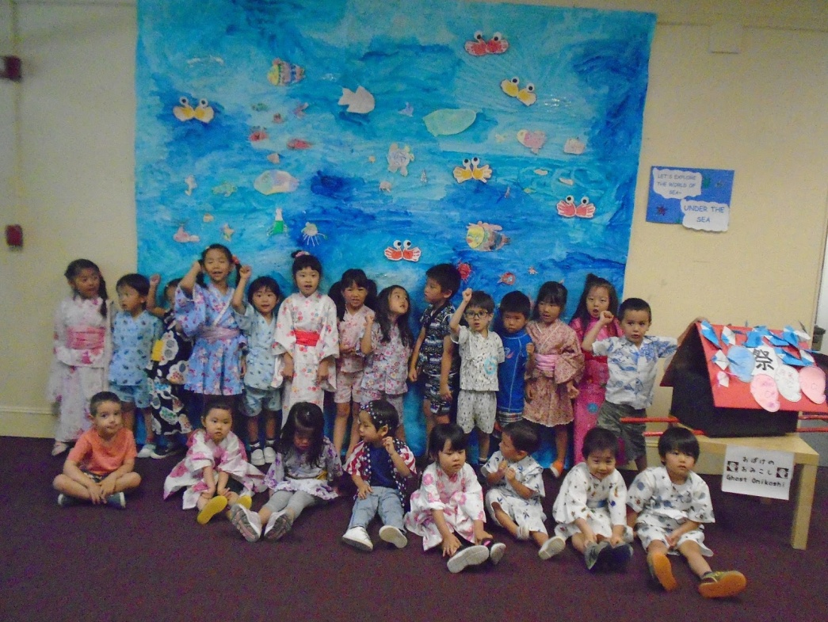

**International Academy of Arts and Sciences**